

PRESS RELEASE Prague, 21st February 2018

PASSERINVEST GROUP once again owner of VILLAS buildings

In January 2018 PASSERINVEST GROUP, a Czech development and investment company, purchased the BB C – Vila Doma buildings (known as VILLAS) from Revetas Capital Fund II. Thus PASSERINVEST GROUP is successfully continuing in its strategy of the long-term ownership and management of the formerly-sold buildings in Prague’s BB Centrum. The financing of this transaction was provided by PASSERINVEST Group from both its own resources and from the revenues from the sale of bonds in 2017.

PASSERINVEST GROUP acquired its first building through the buyback of the ALPHA building in 2014. It gradually also got the ownership of buildings BETA, A, B and D back.

“We started this year with another step in our plan to buy back the BB Centrum office buildings, which we would like to maintain on the highest level over the long term,” commented Radim Passer, the founder and General Director of PASSERINVEST GROUP.

The VILLAS buildings come from the pens of Aulík Fišer architekti. It is comprised of a set of two office buildings with a total area of 8000 m² on six storeys, from which there is 405 m² of retail space on the ground floor and 220 underground parking spots. Tenants with long-term leases in these buildings include Tchibo, GEMALTO and Audatex.
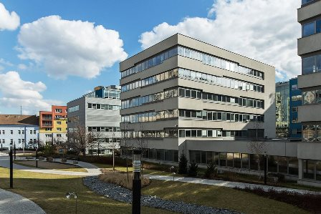

The VILLAS buildings

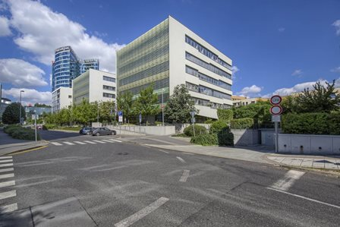

The VILLAS buildings

For more information and photographs in print quality please contact:

Kristýna Samková, Head of PR and Marketing dept.
PASSERINVEST GROUP, a.s.
Tel.: (+420) 221 582 111
Mobil: (+420) 602 186 708
E-mail: Kristyna.Samkova@Passerinvest.cz
www.passerinvest.cz, www.bbcentrum.cz

Marcela Štefcová
Crest Communications a.s.
Mobil: (+420) 731 613 669
E-mail: marcela.stefcova@crestcom.cz

About the Developer

PASSERINVEST GROUP, a.s., founded in 1991 by Radim Passer, is a purely Czech development and investment company whose name is associated in particular with the BB Centrum multifunctional complex in Prague 4 - Michle. With this project, the most successful and extensive Czech project of its type, the company has built its excellent reputation both at home and at the international level. Contributing to this is not only the high quality of the projects completed to date, but also its high level of service, its sense of fair play, its positive relationship with the tenants and users of its buildings, and its sense of responsibility towards society and the environment. PASSERINVEST GROUP’sportfolio includes other interesting development projects.

